**INDEX**

This page allows for comprehensive management of borrower case details, enabling various checks, updates, and actions related to the loan process. Here’s an overview of the sections and options available:

**Current Status**

This section provides an overview of the current stage of the case. The stages include:

* **First E-sign**
* **Sanction**
* **Second E-sign**
* **Disbursed**

Other key options available on this page are:

* **Download Account Opening Form**: Retrieve the form used to open the borrower’s account.
* **Download Signed Loan Agreement**: Access the signed loan agreement document.
* **Download House Visit Form**: Download the form related to the borrower’s house visit.
* **Generate CRIF Report for Case**: Generate the Credit Information Report (CRIF) for the case.
* **Download CRIF Report**: Access the CRIF report generated for the case.
* **Get Account Aggregator Details**: Retrieve the details related to the borrower’s account aggregator.
* **See Geo Locations for this Case**: View the geo-location details linked to the case.
* **Download Pronote or DP Note for Case**: Access the Pronote or Demand Promissory Note for the case.
* **Download PDD Documents**: Download Post-Disbursal Documents related to the case.

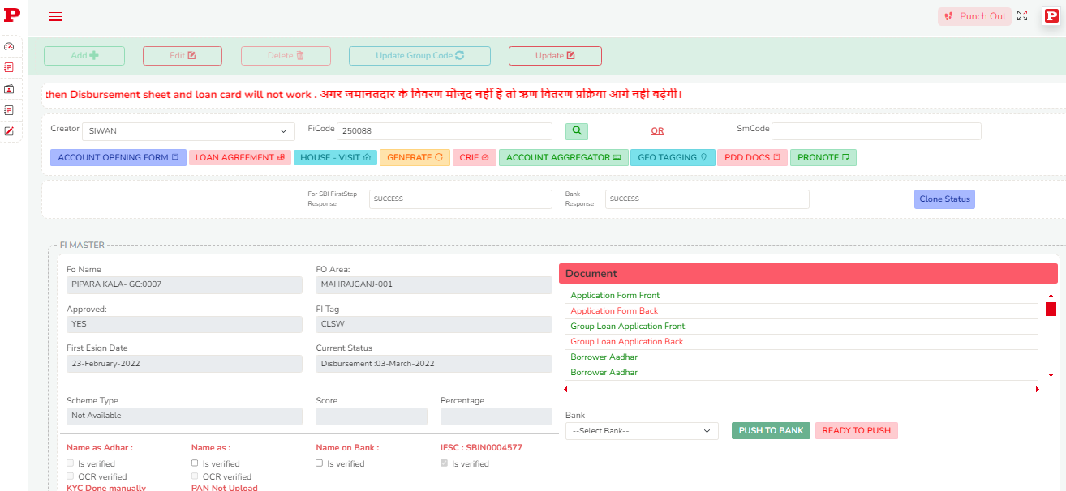

**Verification Details**

This section allows you to check the verification status of the case documents and the KYC IDs associated with the borrower. It also provides the ability to verify the identity of the person and confirm whether their documents are properly validated.

**Group and Branch Details**

Here, you can access details regarding the specific group and branch associated with the case. This information helps in understanding the case's organizational context.

**Case Progression**

The “Case can be Proceeded or Not” section provides an option to determine whether the case is ready to move forward. The **Approved option** indicates whether the case has been approved to proceed further or not.

**Push Case for Sanction**

This feature enables you to check the eligibility of the case for sanction. If the case qualifies, it can be pushed to a specific bank (from the listed bank dropdown) for sanctioning.

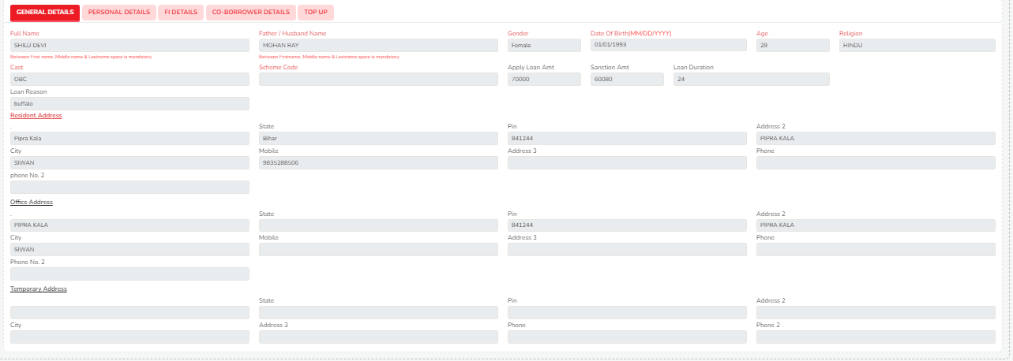

**Sections in the Index Page**

* **General Section**: Displays basic details about the borrower, case code, and other essential information.
* **Personal Section**: Includes the borrower’s bank details, income and expense amounts, and KYC ID details.
* **FI Details**: Displays additional information about the borrower’s living situation.
* **Co-Borrower Details**: Provides information about the guarantor or co-borrower associated with the loan.
* **Top-Up Section**: Allows you to view details related to any top-up loan request or additional borrowing associated with the case.

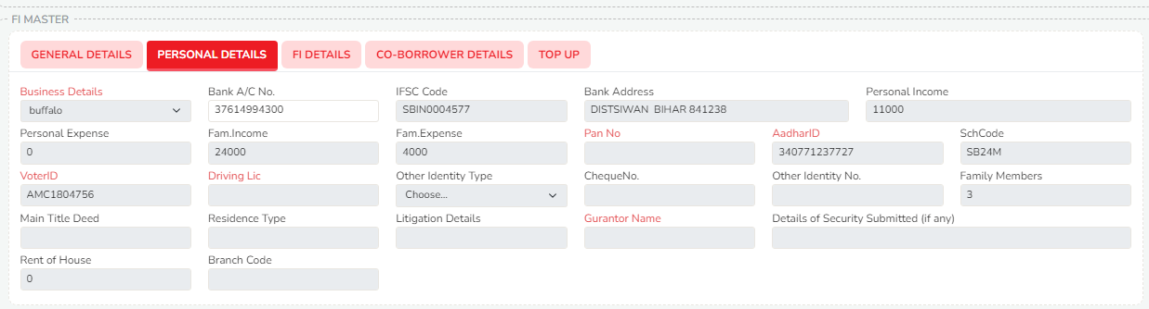

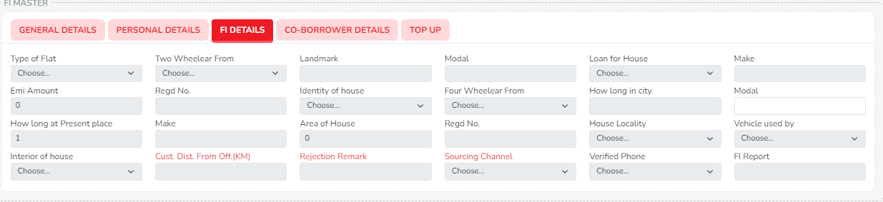

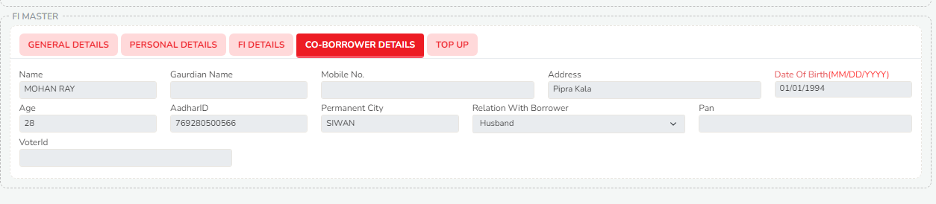

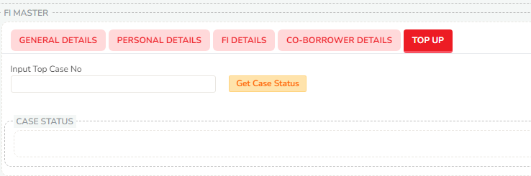

**Case Management Actions**

* **Add Button**: By clicking the Add button, you can create a new Financial Institution (FI) with the same details.
* **Update Group**: You have the ability to update the group associated with the case.
* **Update Case Details**: This allows you to make necessary updates to case details before sanctioning.

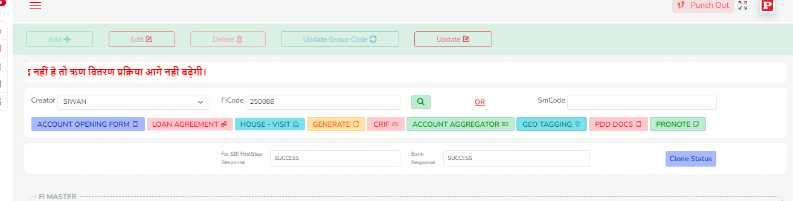

This page centralizes all relevant borrower data and case status, providing the tools to manage the case's progression from application to disbursal. It also ensures that documents are verified and that the case can be appropriately pushed forward for sanction.